IBM – DOCUMENTATION



Industry Mentor(s) Name DIVYA

Faculty Mentor(s) Name S.MANJU BHARATHI

**Team ID:PNT2022TMID38948**

**Names and Reg.No**

Team Leader : INDIRA DEVI M - 421319106013

Team Member : VIDHYA S - 421319106040

Team Member : SANGEETHAPRIYA K - 421319106030

Team Member : RANGEELA P - 421319106028



DEPARTMENT OF ELECTRONICS AND COMMUNICATION ENGINEERING

**KRISHNASAMY COLLEGE OF ENGINEEERING AND TECHNOLOGY**

**ANNA UNIVERSITY:: 2019-2023**

|  |  |  |
| --- | --- | --- |
| ***S.NO*** | ***Table of Content*** | ***Page.No*** |
| ***1*** | ***Introduction*** |  |
| *1.1* | *Project Overview* |  |
| *1.2* | *Purpose* |  |
| ***2*** | ***Literature Survey*** |  |
| ***3*** | ***Ideation & Proposed Solution*** |  |
| *3.1* | *Empathy Map Canvas* |  |
| *3.2* | *Ideation and Brainstorming* |  |
| *3.3* | *Proposed system* |  |
| *3.4* | *Problem solution fit* |  |
| ***4*** | ***Requirement Analysis*** |  |
| *4.1* | *Functional Requirement* |  |
| *4.2* | *Non-Functional Requirement* |  |
| ***5*** | ***Project Design*** |  |
| *5.1* | *Data flow diagram* |  |
| *5.2* | *Solution Architecture* |  |
| *5.3* | *User stories* |  |
| ***6*** | ***Project Planning & Scheduling*** |  |
| *6.1* | *Sprint planning & Estimation* |  |
| *6.2* | *Sprint delivery schedule* |  |
| ***7*** | ***Coding and Solutioning*** |  |
| ***8*** | ***Testing*** |  |
| *8.1* | *Test cases* |  |

|  |  |  |
| --- | --- | --- |
| *8.2* | *User Acceptance Testing* |  |
| ***9*** | ***Results*** |  |
| ***10*** | ***Advantages & Disadvantages*** |  |
| ***11*** | ***Conclusion*** |  |
| ***12*** | ***Future Scope*** |  |
| ***13*** | ***Appendix*** |  |

INTRODUCTION:

1.1 Project Overview:

In our society, we have people with disabilities. The technology is developing day by day but no significant developments are undertaken for the betterment of these people.

Communications between deaf-mute and a normal person has always been a challenging task. It is very difficult for mute people to convey their message to normal people. Since normal people are not trained on hand sign language. In emergency times conveying their message is very difficult. The human hand has remained a popular choice to convey information in situations where other forms like speech cannot be used. Voice Conversion System with Hand Gesture Recognition and translation will be very useful to have a proper conversation between a normal person and an impaired person in any language.

**1.2 Purpose:**

The project aims to develop a system that converts the sign language into a human hearing voice in the desired language to convey a message to normal people, as well as convert speech into understandable sign language for the deaf and dumb. We are making use of a convolution neural network to create a model that is trained on different hand gestures. An app is built which uses this model. This app enables deaf and dumb people to convey their information using signs which get converted to human-understandable language and speech is given as output.

1. **LITERATURE SURVEY:**
2. **TITTLE:** Arduino and remote based gesture keyboard
3. **AUTHOR:** Tahseen Haroon &Vidya Chitre
4. **YEAR:** 2020

## Abstract:

Different keyboars are available in the market,with variation in size,layout,programs and functinalities.Recently,virtual keyboards are also in use but for every single keyboard,the user should remember the arrangements of keys in order to enter different characters.Remote-based gesture keyboard is a system that serves on the Internet of Things [IoT] architecture and embedded with arduino as well as accelerometer and machine learning process that enforces the system to perform in the desired direction.The Remote-based gesture keyboard is the model where the user can enter text and number in a text editor by moving the hand to the specific motion of characters in the air using arduino.Arduino operates as a remote were gesture relocate into the air,translating into letters and exposing them on a computer screen.

**TITTLE:** Gesture driven virtual keyboard

**AUTHOR:** Smita Tripathi,Somdatta Saha,J.Pradeepa

**YEAR:** 2018

## Abstract:

Today’s computer trend follows the rule of “smaller and faster” ,virtual keyboard is just another example of it which is narrowing the gap betwwen human computer interaction .Till now the works have focused mainly on designing and implementing the virtual keyboard.using an external hardware.This paper describes the way of implementing the virtual keyboard without any additional hardware but by using the web cam available in the system. The webcam simply capture the consecutive frames and compares them to regcognise it as a click if there is a difference in the contour .

1. **TITTLE:** Accelarometer based wireless gesture controlled robote for medical assistance using arduino lily pad.

**AUTHOR:** Saikat Mukherjee,Mainakdhar,Arpita Ghosh

**YEAR:** 2018

**Abstract**:

This paper represent the medical assistants system,which can be controlled wirelessly via gesture ,for specially abled people.A sensor (accelarometer) detects the gesture or change in the gesture through which the patient will control the robot for assistance and a microcontroller will command wirelessly,depending upon sensor’s value to working outside and doing great at it. So, an eﬃcient system must be set up, to interact with them, to know their views and ideas. The framework here, act as a communication system fordeaf and dumb individuals. It would take the sign language as an input which would display the result not only in the form of text but also in the form of audio. Similarly, if there is any input in the form of text, it would display the corresponding image.

**Limitations:** The proposed framework is good for recognizing hand gestures. But it is notfeasible in every environment.

1. **TITTLE:** Artiﬁcial Intelligence enabled virtual sixth sense application for the disabled.

**AUTHOR:** Muhammad Usman Tariq

**YEAR:** 2020

## Abstract:

The main purpose of this research is to enhance the communication of the disabled community.The author of this chapter propose an enhanced interpersonal human interaction disabilities. The proposed model comprises of automated real time behavior monitoring designed and implemented with the ubiquitous and affordable concept in mind to suit the under privileged.In this chapter ,the authors present the prototype which encapsulates an automatedfacial expression recognition system for monitoring the disabled equipped with a gesture to send short messaging system(SMS) for notiﬁcation purposes.The authors adapted the viola- jones face depression algorithm at the face detection stage and implemented template matching technique for the expression classiﬁcation and recognition stage.They tested their model with a few users and achieved satisfactory results.The enhanced real time behavior monitoring system is an assistive tool to improve the qualify of life for the disabled by assitingthem anytime and anywhere when needed. They can do this own tasks more independently without constantly being monitored physically or accompanied by this care takers teachers or even parents.The rest of this chapter is organized as follows.The background of the facial expression recognition system is reviewed .

## CONCLUSION:

From the above literature survey, we can conclude that all those papers follow a more or less similar methodology. We also like to follow that methodology with some improvements toovercome some of the limitations mentioned above. The input image is processed to isolate the hand. Then it is passed to a trained convolution neural network to identify the gesture with greater accuracy.

## IDEATION & PROPOSED SOLUTION :

* 1. **Emathy Map Canvas:**

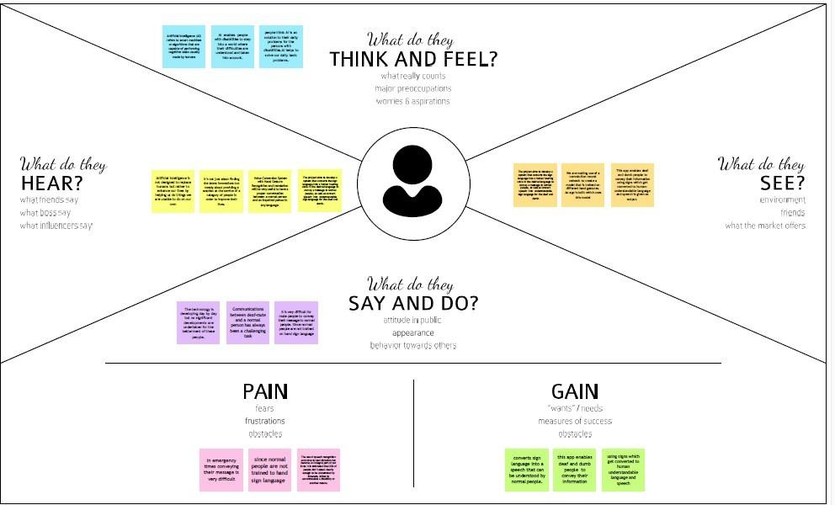

## Ideation and Brainstorming

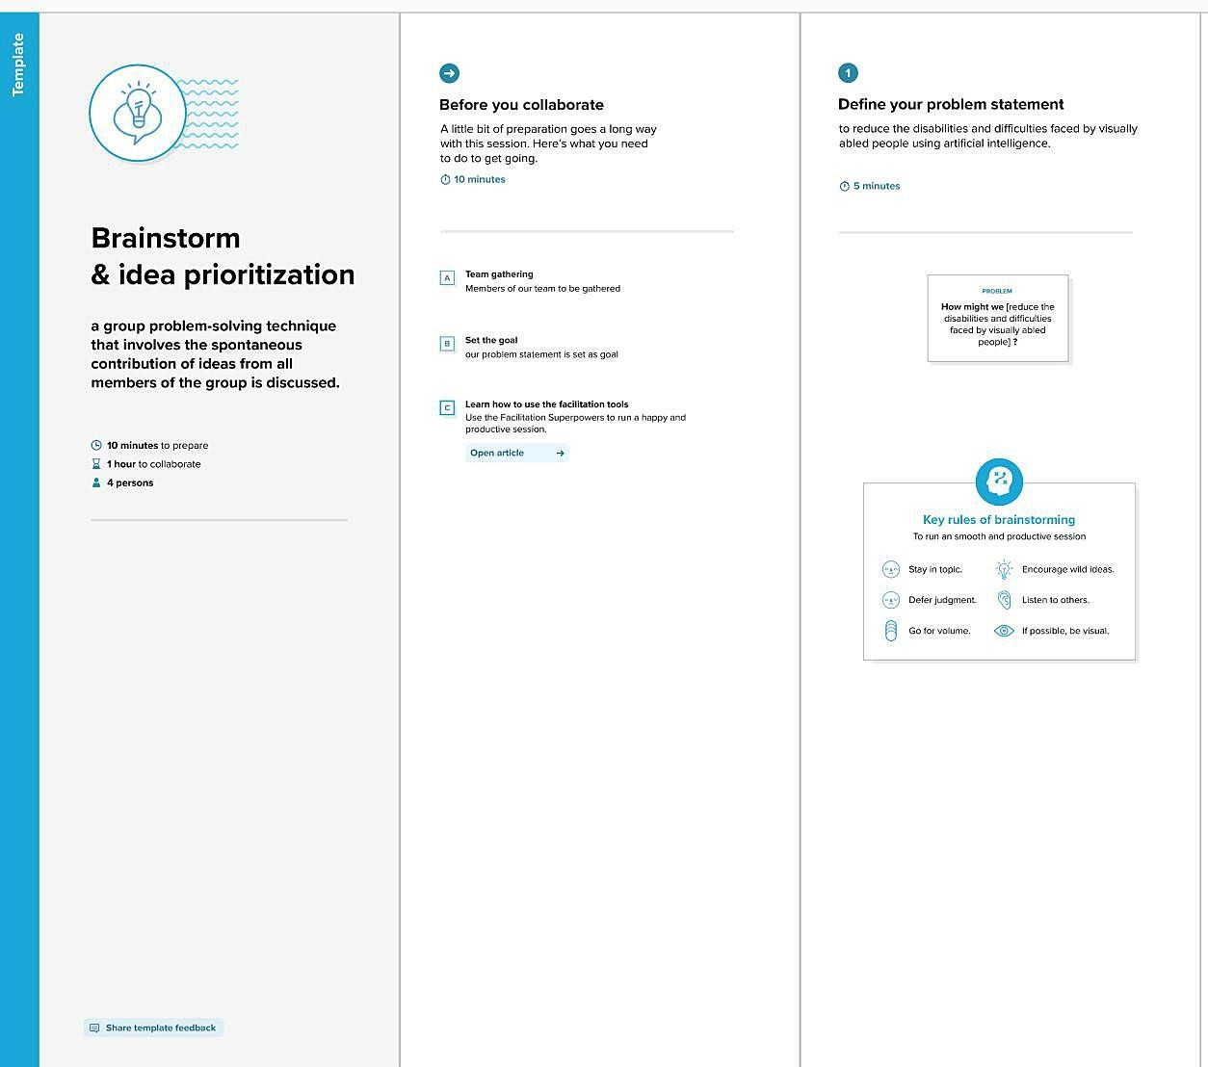

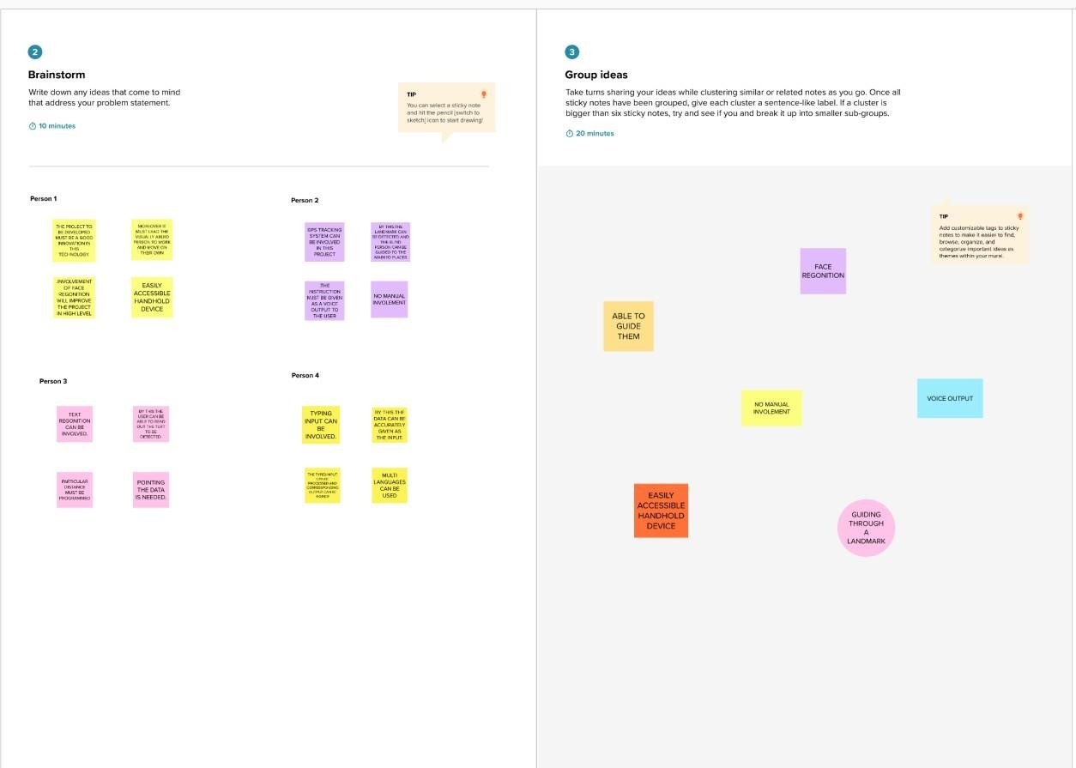

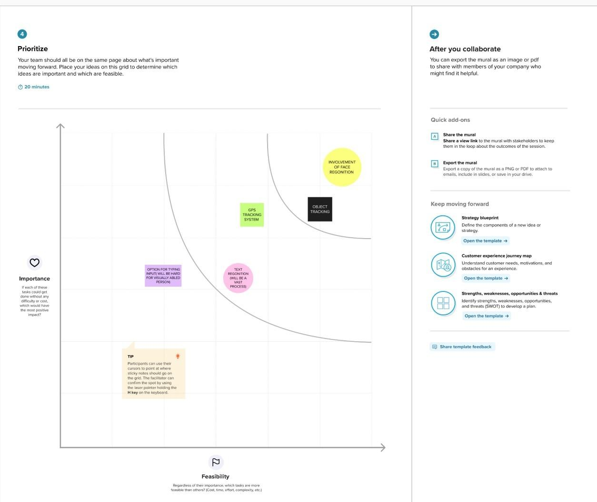

|  |  |  |
| --- | --- | --- |
| **S.No** | **Parameter** | **Description** |
| 1. | Problem Statement(problem to be solved) | **Statement-**Communication between deaf- mute and a normalperson has always been a challenging task.  **Description** : It is very diﬃcult |

|  |  |  |
| --- | --- | --- |
|  |  | for mute people to convey theirmessage to normalpeople in emergency times as well as in  normal times. |
| 2. | Idea/Solution Description | 1. The ideas consisted of designing and implement a system using artiﬁcial intelligence, image processing and data miningconceptsto takeinput as handgestures. 2. It generates recognizable outputs in theform of text and voice with 91% accuracy |
| 3. | Novelty/Uniqueness | 1. Artiﬁcial Intelligence developed the app called **GnoSys** uses neural networks andcomputer. 2. It recognizes the video of sign language speaker, andthen smartalgorithms translateit into speech. |
| 4. | Social Impact/Cutomer Statisﬁcation | 1. About two thirds of People with a mobilityand dexterity disability are most likely to experience agreat deal of diﬃculty witheveryday activities. 2. The main purpose of this application is to makedeaf- mute people feelindependent andmoreconﬁdent. |
| 5. | Business Model (RevenueModel) | 1. AI can generate revenue through direct customers and collobrate with health caresector and generate revenue from their customers. |

|  |  |  |
| --- | --- | --- |
|  |  | 2. B2B setting uses to employ deaf and mute employees can use to convey messages according to the company. |
| 6. | Scalability Solution | 1. AI technology helping disabled people opensup new opportunities for accessibility inclusion insociety and independent living. 2. It could unlock more advanced and innovative solutions for addressing themost complex challenges facedby disbled peoples. |

## Problem Solution Fit:

1. **REQUIREMENT ANALYSIS**

## Functional Requirement:

|  |  |  |
| --- | --- | --- |
| **FR.No** | **Functional Requirement(Epic)** | **Sub Requirement (Story/Sub-Task)** |
| FR-1 | User Registration | Registration through Gmail |
| FR-2 | User Conﬁrmation | Conﬁrmation through Gmail |
| FR-3 | Registration for test and train folders | The user must be conﬁrmed with thetest and train folder which is to be  recognised. |
| FR-4 | Registration for GPS location | The location must be registered. |
| FR-5 | Input must be given | By Image Processing |
| FR-6 | Location must be given | Location can be given as voice messagae for tracking the location. |
| FR-7 | Functional Requirement done | Voice outputs will be given. |

* 1. **Non Functional Requirements:**

|  |  |  |
| --- | --- | --- |
| **NFR.No** | **Non-Functional Requirements** | **Description** |
| NFR-1 | Usability | This device can be helpful tothe blind peoples to know about their surroundings and environment |
| NFR-2 | Security | The device will be only accessible by the user through Gmailconﬁrmation andthe data willnotbe  hackedin ease. |
| NFR-3 | Reliability | The device will be more reliable because we use accurate sensorsand GPS  systems. |
| NFR-4 | Performance | The performance of the device  is high in speed and low power usage so that the user |

|  |  |  |
| --- | --- | --- |
|  |  | can use without interruptions. |
| NFR-5 | Availability | The devicewill be available in the marketto buy it. |
| NFR-5 | Scalability | The scalability of the device is high in terms ofnetwork and GPS issues. |

## PROJECT DESIGN

* 1. **Data Flow Diagrams:**

A Data Flow Diagram (DFD) is a traditional visual representation of the information ﬂows within a system. A neat and clear DFD can depict the right amount of the system requirement graphically. It shows how data enters and leaves the system, what changes the information, and where data is stored.

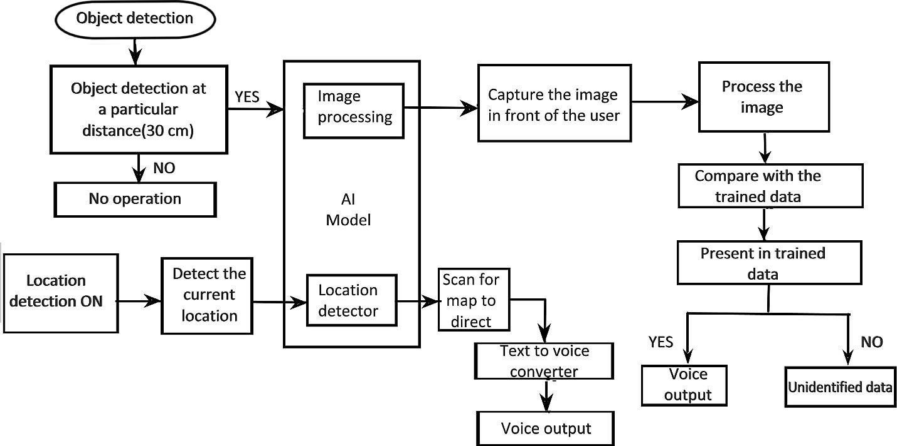

Here the device detects the object and if the object is detected at a particular distance of 30 cm, image processing takes place by capturing ,processing and comparing the detected image with the trained data. If the image is present in the trained data, then the device provides the outputin the form of a voice signal. If the image does not match with the trained data, then the devicegives the output as unidentiﬁed data. The location detector in the AI model is used to detect the current location of the user an data in the form of a voice signal.

## Solution Architecture:

|  |  |  |  |  |  |  |
| --- | --- | --- | --- | --- | --- | --- |
| **User Type** | **Functional Requireme nt** | **User Story Number** | **User Story/ Task** | **Acceptance criteria** | **Priority** | **Release** |
| Customer (Mobile user) | Registration | USN-1 | As a user, I can register for the  application by entering my email, password, and conﬁrming my password. | I can access my account  /dashboard | High | Sprint-1 |
|  |  |  | As a | I can |  |  |

|  |  |  |  |  |  |  |
| --- | --- | --- | --- | --- | --- | --- |
|  |  | USN-2 | user,I will receive conﬁrm ation email once I have register ed for the applica tion | receive conﬁrmati onemail &click conﬁrm | High | Sprint-1 |
|  |  | USN-3 | As a user,I can register for the applicati on through Gmail. | I can receive veriﬁcati oncode and invitation | Medium | Sprint-1 |
| Administrat or | Login | USN-4 | As a user, I can loginto the applicati on byenteri ng email &passw ord | I can loginto my account | High | Sprint-1 |
| Cust omer Servi ce | Traini ng data | USN-5 | Ask for thetrained data to be added. | I am adding the trained data to get the image recogni zed. | High | Sprint-1 |
| Customer | Object Detection | USN-6 | Detecting the object within | I can sense any objects | High | Sprint-2 |

|  |  |  |  |  |  |  |
| --- | --- | --- | --- | --- | --- | --- |
|  |  |  | 30 cm distance | that are at a distance of 30 cm. |  |  |
| Customer | Location detection | USN-7 | Detecting the location in the map. | I can set the destination to be reached. | High | Sprint-2 |
| Customer Service | Capture the Image | USN-8 | Captures the image and detects the image using image processing. | I can check for the image in trained data | High | Sprint-3 |
| Customer Service | Location ﬁx | USN-9 | The path will be ﬁxed. | I can know the direction which will be given as voice output. | High | Sprint-4 |
| Customer Service | Person/Object ﬁx | USN-10 | The name of the person or the object is detected. | I can get a voice output if the name is registered in the trained data. | High | Sprint-4 |

## PROJECT PLANNING & SCHEDULING

* 1. **Sprint Planning & Estimation:**

|  |  |  |  |
| --- | --- | --- | --- |
| **Milestone** | **Functional Requirement(Epic)** | **Milestone Story number** | **Milestone Story and Task** |
| Milestone-1 | Data Collection | M1 | We are collecting dataset for building our project and creating to folders, one for training and another one for  testing |
| Milestone-2 | Image Processing | M2 | Importing image data generator libraries and applying image data generator functionally to train |

|  |  |  |  |
| --- | --- | --- | --- |
|  |  |  | the test set. |
| Milestone-3 | Building Model | M3 | Importing the model building libraries, Insulation the model, Adding Convolution layers, Adding the Polling layers, Adding the Flatten layers, Adding Dense layer, Compiling the model Fit and  Save the model. |
| Milestone-4 | Testing Model | M4 | Import the packages ﬁrst. Then we save the model andLoad the test image. Pre-  progress it and predict it. |
| Milestone-5 | Application layer | M1 | Build the ﬂask application and the HTML pages. |
| Milestone-6 | Train Conversation Engine | M2 | Register for IBM cloud and train image classiﬁcation model |
| Milestone-7 | Final Result | M3 | To ensure all the activities and resulting the ﬁnal output. |

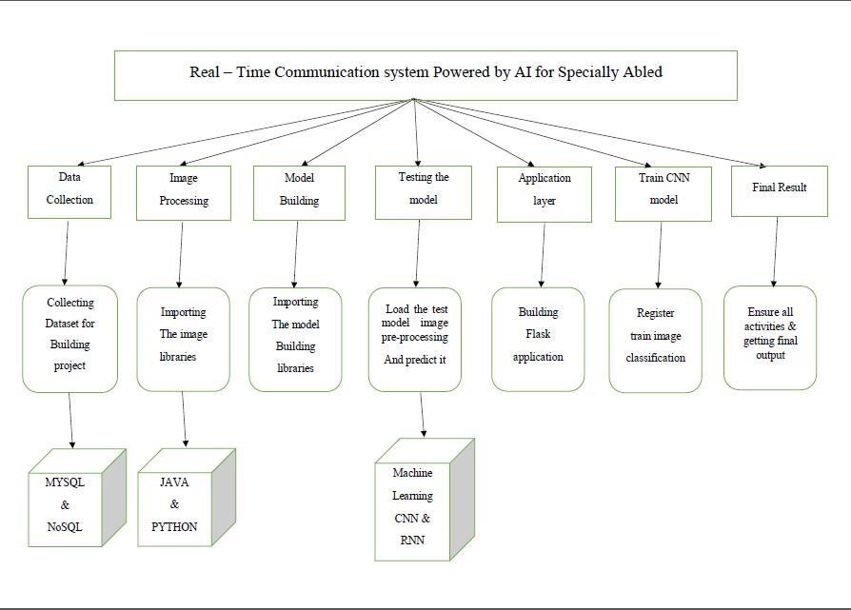

## Sprint Delivery Schedule:

|  |  |  |  |  |  |  |
| --- | --- | --- | --- | --- | --- | --- |
| **sprint** | **Functional Requireme nt (Epic)** | **User Story Number** | **User Story/ Task** | **Story Points** | **Priority** | **Team Member** |
| Sprint-1 | Registration | USN-1 | As a user, I will receive conﬁrmati on email once I have registered for the application | 2 | High | Indira devi |
| Sprint-2 | Registration | USN-2 | register for the application | 1 | High | Vidhya |

|  |  |  |  |  |  |  |
| --- | --- | --- | --- | --- | --- | --- |
|  |  |  | throughphone number |  |  |  |
| Sprint-2 | Registration | USN-3 | Profession al responsible for user requiremen ts & needs | 2 | Medium | Rangeela |
| Sprint-2 | User Interface | USN-4 | As a user, I can log into the application by entering email & password | 2 | Medium | Sangeetha priya |
| Sprint-3 | Login | USN-5 | As a user, I should get notiﬁcation about the progress and any updates viaemail or sms | 1 | High | Rangeela |
| Sprint-4 | Privacy | USN-8 | The developed application should be secure for the users | 2 | High | Sangeethapri ya |

**Real-Time Communication System Powered by AI for Specially Abled- PNT2022TMID41429 Team Leader:** M.Indira devi

**Team Members:** S.Vidhya K.Sangeetha priya P.Rangeela

## CODING AND SOLUTIONING

import os import cv2

import numpy as np

import matplotlib.pyplot as plt

from keras.preprocessing.image import ImageDataGenerator

**Deﬁne DATA FILES**

**def** rename_imgs(ﬁle_name):

r'test_dataset/'**+**ﬁle_name

|  |  |
| --- | --- |
| folder_path **=** | |
| num  **for** | **=** 0  ﬁle **in** os. |

listdir(folder_path):

*# if num%10 == 0:*

*# print(f'Renamed {num} ﬁles...')*

*# os.rename(folder_path+'\\'+ﬁle, folder_path+'\\'+ﬁle_name+'_'+str(num)+'.jpeg')*

num **+=** 1

ile_names = '0123456789'+'ABCDEFGHIJKLMNOPQRSTUVWXYZ'

for fn in ﬁle_names: rename_imgs(fn)

**SAMPLE IMAGES FROM DATASET**

train_data_path **=** 'train_dataset/' test_data_path **=** 'test_dataset/'

**def** display(img,sign**=None**):

In [ ]:

In [ ]:

In [ ]:

img **=** cv2.cvtColor(img,cv2.COLOR_BGR2RGB)

ﬁg **=** plt.ﬁgure(ﬁgsize**=**(7,7))

ax **=** ﬁg.add_subplot(111)

plt.title(sign)

ax.imshow(img)

**Training Data Set**

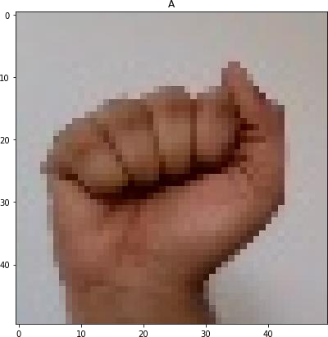sign_img = cv2.imread(train_data_path+'A/A_204.jpeg') display(sign_img,'A')

In [ ]:

sign_img = cv2.imread(train_data_path+'3/3_340.jpeg') display(sign_img,'3')

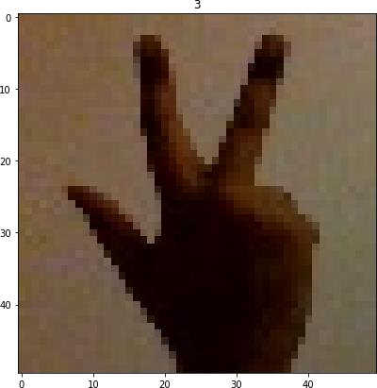



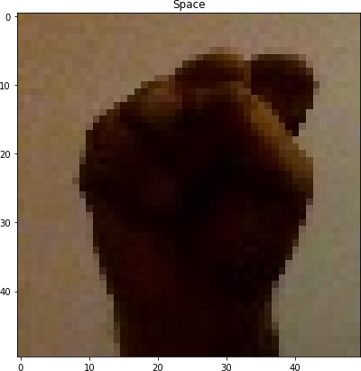sign_img = cv2.imread(train_data_path+'S/S_10.jpeg') display(sign_img,'Space')

## TEST DATA SET

sign_img = cv2.imread(test_data_path+'S/S_15.jpeg') display(sign_img,'S')

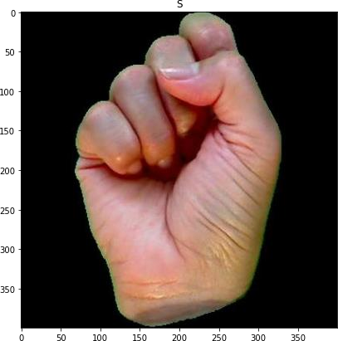

sign_img = cv2.imread(test_data_path+'Z/Z_1.jpeg') display(sign_img,'Z')

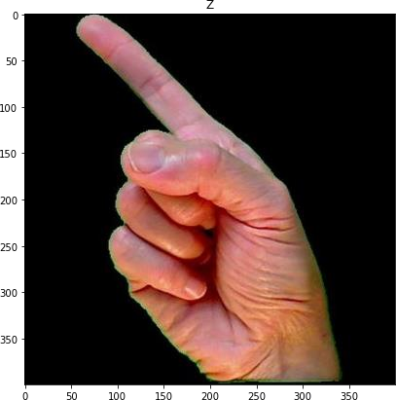

## IMAGE DATA GENERATOR

image_gen = ImageDataGenerator(rotation_range=30,

width_shift_range=0.1, height_shift_range=0.1, shear_range=0.2, zoom_range=0.2, rescale=1/255, horizontal_ﬂip=True, ﬁll_mode='nearest', validation_split=0.25)

## ORIGINAL IMAGE

sign_img = cv2.imread(train_data_path+'3/3_100.jpeg') display(sign_img,'3')

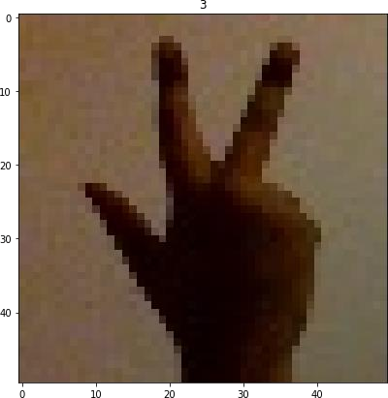

## AUGMENTED IMAGE

display(image_gen.random_transform(sign_img))

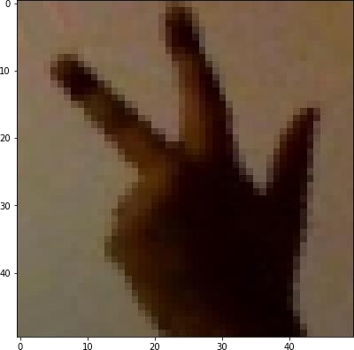

## SPLIT INTO TEST AND VALIDATION DATASET

**TRAIN DATA GENERATOR**

train_data_gen = image_gen.ﬂow_from_directory(train_data_path,

target_size=(250,250), batch_size=16, shuﬄe=True, class_mode='binary', subset='training')

Found 41625 images belonging to 37 classes.

**Validation Data Generator**

validation_data_g

validation_data_gen = image_gen.ﬂow_from_directory(train_data_path,

target_size=(250,250), batch_size=16, shuﬄe=True,

In [ ]:

class_mode='binary', subset='validation')

Found 13875 images belonging to 37 classes.

## TEST DATA GENERATOR

test_data_gen = image_gen.ﬂow_from_directory(test_data_path,

target_size=(250,250), batch_size=8, shuﬄe=True, class_mode='categorical',

)

Found 2586 images belonging to 37 classes.

train_data_gen.class_indices In [ ]:

|  |  |
| --- | --- |
| {'0': | 0, |
| '1': | 1, |
| '2': | 2, |
| '3': | 3, |
| '4': | 4, |
| '5': | 5, |
| '6': | 6, |
| '7': | 7, |
| '8': | 8, |
| '9': | 9, |
| 'A': | 10, |
| 'B': | 11, |
| 'C': | 12, |
| 'D': | 13, |
| 'E': | 14, |
| 'F': | 15, |
| 'G': | 16, |
| 'H': | 17, |
| 'I': | 18, |
| 'J': | 19, |
| 'K': | 20, |
| 'L': | 21, |
| 'M': | 22, |
| 'N': | 23, |
| 'O': | 24, |
| 'P': | 25, |
| 'Q': | 26, |

'R': 27,

'S': 28,

'Space': 29,

|  |  |
| --- | --- |
| 'T': | 30, |
| 'U': | 31, |
| 'V': | 32, |
| 'W': | 33, |
| 'X': | 34, |
| 'Y': | 35, |
| 'Z': | 36} |

test_data_gen.classes

array([ 0, 0, 0, ..., 36, 36, 36])

len(train_data_gen.classes) 41625

## TESTING

* 1. **Test Cases:**

#import imagedatagenerator

from keras.preprocessing.image import ImageDataGenerator

##import imagedatagenerator

from keras.preprocessing.image import ImageDataGeneratortraining datagen train_datagen=ImageDataGenerator(rescale=1./255,shear_range=0.2,zoom_range=0.2,horizontal_ﬂip=True) #testing datagen

test_datagen=ImageDataGenerator(rescale=1./255)

## IMPORTING tensorﬂow

#testing datagen test_datagen=ImageDataGenerator(rescale=1./255)import tensorﬂow as tfimport os

## INITIALIZE THE MODEL

#create model

from keras.models import Sequentialfrom keras.layers import Dense

from keras.layers import Convolution2D from keras.layers import MaxPooling2D from keras.layers import Dropout

from keras.layers import Flatten

from tensorﬂow.keras.preprocessing.image import ImageDataGenerator

import numpy as np

import matplotlib.pyplot as plt #to view graph in colab itselfimport IPython.display as display

from PIL import Image import pathlib Unzipping the dataset

!unzip '/content/conversation engine for deaf and dumb (1).zip' Applying ImageDataGenerator to training set

x_train=train_datagen.ﬂow_from_directory('/content/Dataset/training_set',target_size=(64,64),batch_ size=200,

class_mode='categorical',color_mode="grayscale")

Found 15750 images belonging to 9 classes.

Applying ImageDataGenerator to test set

x_test=test_datagen.ﬂow_from_directory('/content/Dataset/test_set',target_size=(64,64),batch_size= 200,

class_mode='categorical',color_mode="grayscale")

Found 2250 images belonging to 9 classes.

a**=**len(x_train) b=len(x_test)

Length of training set

In [ ]:

print(a) 79

Length of Test Set print(b)

12

Add Layers #create model model=Sequential()

Add the Convolution Layer

model.add(Convolution2D(32,(3,3),input_shape=(64,64,1),activation='relu'))

Add the Pooling Layer

model.add(MaxPooling2D(pool_size=(2,2)))

Add the Flatten Layer model.add(Flatten())

Adding the Dense layer #1st hidden layer

model.add(Dense(units=512,activation='relu')) #2nd hidden layer model.add(Dense(units=261,activation='relu'))

#output layer model.add(Dense(units=9,activation='softmax'))

**COMPILE THE MODEL**

model.compile(loss='categorical_crossentropy',optimizer='adam',metrics=['a ccuracy'])

Fit the Model

model.ﬁt_generator(x_train,steps_per_epoch=len(x_train),epochs=10,validati on_data=x_test,validation_steps=len(x_test))

|  |  |  |
| --- | --- | --- |
| Epoch 1/10  79/79 [==============================] - 90s 1s/step - loss: | 0.3965 | - |
| accuracy: 0.8746 - val_loss: 0.2797 - val_accuracy: 0.9529 |  |  |
| Epoch 2/10 |  |  |
| 79/79 [==============================] - 86s 1s/step - loss: | 0.0419 | - |
| accuracy: 0.9884 - val_loss: 0.2846 - val_accuracy: 0.9751 |  |  |
| Epoch 3/10 |  |  |
| 79/79 [==============================] - 84s 1s/step - loss: | 0.0195 | - |
| accuracy: 0.9947 - val_loss: 0.3436 - val_accuracy: 0.9751 |  |  |
| Epoch 4/10 |  |  |

|  |  |  |
| --- | --- | --- |
| 79/79 [==============================] - 87s 1s/step - loss: | 0.0083 | - |
| accuracy: 0.9982 - val_loss: 0.3722 - val_accuracy: 0.9751 |  |  |
| Epoch 5/10 |  |  |
| 79/79 [==============================] - 83s 1s/step - loss: | 0.0066 | - |
| accuracy: 0.9983 - val_loss: 0.4095 - val_accuracy: 0.9756 |  |  |
| Epoch 6/10 |  |  |
| 79/79 [==============================] - 88s 1s/step - loss: | 0.0072 | - |
| accuracy: 0.9979 - val_loss: 0.3874 - val_accuracy: 0.9756 |  |  |
| Epoch 7/10 |  |  |
| 79/79 [==============================] - 86s 1s/step - loss: | 0.0059 | - |
| accuracy: 0.9985 - val_loss: 0.3891 - val_accuracy: 0.9747 |  |  |
| Epoch 8/10 |  |  |
| 79/79 [==============================] - 86s 1s/step - loss: | 0.0027 | - |
| accuracy: 0.9992 - val_loss: 0.4429 - val_accuracy: 0.9756 |  |  |
| Epoch 9/10 |  |  |
| 79/79 [==============================] - 84s 1s/step - loss: | 0.0073 | - |
| accuracy: 0.9981 - val_loss: 0.4907 - val_accuracy: 0.9756 |  |  |
| Epoch 10/10 |  |  |
| 79/79 [==============================] - 85s 1s/step - loss: | 0.0048 | - |
| accuracy: 0.9987 - val_loss: 0.4866 - val_accuracy: 0.9702 |  |  |

Out[23]:

<keras.callbacks.History at 0x7f445adcd7d0>

Save the Model model.save('aslpng2.h5')

Import The Packages And Load The Saved Model

from tensorﬂow.keras.models import load_model import numpy as np

import cv2

from tensorﬂow.keras.preprocessing import image

#load the model model=load_model('aslpng2.h5')

img=image.load_img('/content/Dataset/test_set/A/10.png',target_size=(400,500)) img



## User Acceptance Testing

1. **Purpose of Document**

The purpose of this document is to brieﬂy explain the test coverage and open issues of the [ProductName] project at the time of the release to User Acceptance Testing (UAT).

## Defect Analysis

This report shows the number of resolved or closed bugs at each severity level, and howthey were resolved.

|  |  |  |  |  |  |
| --- | --- | --- | --- | --- | --- |
| **Resolution** | **Severity 1** | **Severity 2** | **Severity 3** | **Severity 4** | **Subtotal** |
| By Design | 10 | 4 | 2 | 3 | 20 |
| Duplicate | 1 | 0 | 3 | 0 | 4 |
| External | 2 | 3 | 0 | 1 | 6 |
| Fixed | 11 | 2 | 4 | 20 | 37 |
| Not Reproduced | 0 | 0 | 1 | 0 | 1 |
| Skipped | 0 | 0 | 1 | 1 | 2 |
| Won't Fix | 0 | 5 | 2 | 1 | 8 |
| Totals | 24 | 14 | 13 | 26 | 77 |

## Test Case Analysis

This report shows the number of test cases that have passed, failed, and untested

|  |  |  |  |  |
| --- | --- | --- | --- | --- |
| **Section** | **Total Cases** | **Not Tested** | **Fail** | **Pass** |
| Print Engine | 7 | 0 | 0 | 7 |
| Client Application | 51 | 0 | 0 | 51 |

|  |  |  |  |  |
| --- | --- | --- | --- | --- |
| Security | 2 | 0 | 0 | 2 |
| Outsource Shipping | 3 | 0 | 0 | 3 |
| Exception Reporting | 9 | 0 | 0 | 9 |
| Final Report Output | 4 | 0 | 0 | 4 |
| Version Control | 2 | 0 | 0 | 2 |

## RESULTS Performance Metrics

**Model Performance Testing**

Project team shall fill the following information in model performance testing template.

|  |  |  |  |
| --- | --- | --- | --- |
| **S.No.** | **Parameter** | **Values** | **Screenshot** |
| 1 | Accuracy | Training Accuracy  validation Accuracy |  |
| 2 | Confidence Score Only  yolo Project | Class Detected  Confidence Score |  |

## ADVANTAGES & DISAVANTAGES

**Advantages**

* + Identifying a Disability Helps You Help Your Student.
  + By Law, Kids With Labels Have Access to Special Services.

# reliable – people with disability generally take fewer days off, take less sick leave, are more loyal and stay in jobs longer than other workers. productive

– in the right job with the right support, disabled people perform just as well as other employees.

# Disadvantages

* + Teachers Can Stereotype Students Based on the Label.
  + Special Education Services May Be Costly.
  + **Difficulty With Transportation**: Most people who have disabilities do not have a car, so they must rely on public transportation, which can be difficult for them to navigate. Even getting to a job interview can be tough.

# CONCLUSION

The input image is processed to isolate the hand. Then it is passed to a trained convolution neural network to identify the gesture with greater accuracy.

1. **FUTURE SCOPE**
2. **Digital Photography:** Instead of using ﬁlms and paper sheets to produce pictures, students are taught how to click pictures using a digital camera, and even speciﬁc smartphones and how to edit, store and share them using a computer. Students are taught how to use photography software and publish these photographs on different platforms.
3. **Graphic Design:** A graphic designing course includes studio art, principles of design, computerized design, commercial graphics production, printing techniques, and website design. Students should also have beforehand knowledge of writing. A ﬂair for creativity is required to become a graphic designer, a profession that has become really popular in the last few years.
4. **Management Accounting:** The course helps students learn about commerce, ﬁnancial services at consultancies, government public sector or manufacturing industry. Students learn about evaluating business activities and analyzing stakeholders and regulators.
5. **App Development:** Apps are a signiﬁcant part of every smartphone and given the increasing number of smartphone users, app development is becoming an important course to reach out to speciﬁcally Indian

audiences. Students are taught the basics of creating apps and what goes into the making of them.

**13.APPENDIX**

**IBM-EPBL/I IBM-Project-47528-1660800085**

